
Safeguarding Procedures
- Introduction
The Woodford Wells Club [hereafter referred to as ‘the club’] is committed to the fundamental principle of protecting a person’s right to live in safety free from abuse or neglect. This is developed and sustained through a positive culture of vigilance, implementing learned lessons from incidences and best practice whilst working in partnership with statutory agencies, partner services and organisations.
These safeguarding procedures seek to ensure that the club undertakes its responsibilities to safeguard people consistently and effectively. They provide a framework to support all those who come into contact with the club in order protect them from abuse and maltreatment of any kind.
The procedures clarify the club’s expectations of all individuals working for and with the club including committee members, staff, volunteers, coaches and members in our activities, events, or trips.
- Definitions
An adult is a person who is aged 18
A child is a person who is under the age of 18.
An adult at risk of abuse or neglect as outlined in legislation1 is an adult who:
a. is experiencing or at risk of abuse or neglect; and
b. has needs for care and support (whether or not the authority is meeting any of those needs); and
c. as a result of those cared and support needs is unable to protect themselves against abuse or neglect or the risk of it
A vulnerable adult is an adult that does not fit the criteria of an adult at risk but is someone who is believed to be experiencing or at risk of abuse or neglect but does have care and support needs.
Abuse is the violation of a person’s human, civil or legal rights by another person or persons. Abuse may be a single act, repeated acts and/or multiple acts. It may be physical, verbal, emotional or psychological. It may be perpetrated as a result of deliberate intent, negligence, or ignorance.
Abuse may be an Act of Omission: (failing to act) or neglect. Abuse may involve the person at risk of abuse or neglect being persuaded or forced to enter into a financial or sexual arrangement to which they have not, or cannot, understand or consent.
1Social Services and Well-being (Wales) Act 2014; Care Act 2014

An abuser may be anyone who has contact with the person at risk of abuse or neglect. This may be a family member, carer, friend, professional staff, support staff, Adult Placement Carer, neighbour, volunteers, people in a position of trust, another service user.
Safeguarding Children and promoting the welfare of children is defined as:
• protecting children from maltreatment
• preventing the impairment of children’s mental and physical health or development
• ensuring that children grow up in circumstances consistent with the provision of safe and effective care, and
• taking action to enable all children to have the best outcomes.
Safeguarding Adults means protecting an adult's right to live in safety, free from abuse and neglect.
- Categories of Abuse
The club recognise that the following may indicate abuse and will act appropriately upon receipt of such information.
Physical Abuse: The non-accidental infliction of a physical act that results, or could result, in physical injury, pain or suffering including:
• assault
• hitting
• slapping
• pushing
• misuse of medication
• restraint
• inappropriate physical sanctions

Sexual Abuse: The direct or indirect involvement of a person at risk of abuse or neglect in sexual activity to which they are unwilling or unable to give informed consent or which they do not fully comprehend. Any sexual activity that is not freely consenting is criminal. Where there is an abuse of trust, sexual activity may appear to be with consent, but it is unacceptable because of the differences in power and influence between the people involved. This includes:

• rape
• indecent exposure
• sexual harassment
• inappropriate looking or touching
• sexual assault
• sexual teasing or innuendo
• sexual photography
• subjection to pornography or witnessing sexual acts • sexual acts to which the adult has not consented or was pressured into consenting.
Neglect: This can be intentional and unintentional acts. It includes ignoring care needs or withholding or deliberately not providing care to a person at risk of abuse or neglect. It includes the unintentional failure to provide support because of lack of knowledge or understanding of the need for services. It includes failure to follow support plans, policies and procedures. Failure to provide prescribed medication and provide poor nutrition.
Emotional/Psychological Abuse: The violation of the emotional and psychological health and development of the person at risk of abuse or neglect. This includes threats of harm, bullying, humiliation, verbal abuse, isolation or withdrawal from services or support networks, coercion, control and intimidation.
Domestic Abuse: Any incident or pattern of incidents of controlling, coercive, threatening behaviour, violence, or abuse between those aged 16 or over who are, or have been, intimate partners or family members regardless of gender or sexuality. The abuse can encompass, but is not limited to psychological, physical, sexual, financial, emotional, or so called ‘honour’ based violence.
Financial Abuse: Includes theft, fraud, pressure around wills, property or inheritance, the misuse or misappropriation of benefits or monies.
Discriminatory Abuse: Includes harassment, slurs or similar treatment because of race, gender and gender identity, age, disability, sexual orientation, or religion.
Self-neglect: This covers a wide range of behaviour neglecting to care for one’s personal hygiene, health, medication (when indicated), safety precautions or surroundings and incudes behaviour such as hoarding. This excludes a situation in which a mentally competent person who understands the consequences of their decisions, makes a conscious and voluntary decision to engage in an act that threatens their own health or safety.

Organisational Abuse: Includes neglect and poor care practice within an institution or specific care setting such as a hospital or a care home for example, or in relation to care provided in one’s own home. This may range from a one-off incident to ongoing- ill-treatment. It can be through neglect or professional practice as a result of the structure, policies, processes, and practices within an organisation.
Modern Slavery: Modern slavery is the severe exploitation of other people for personal or commercial gain. It includes slavery, human trafficking, forced labour and domestic servitude, traffickers and slave masters using whatever means they have at disposal to coerce, deceive, and force individuals into a life of abuse, servitude and inhumane treatment.
Radicalisation and Extremism: Radicalisation is a process which somebody goes through in order to become involved in extremist activities or terrorism, from a starting point of having no particular strong opinions or being a moderate person through to holding some extremist views, and it can be a process that happens online or in meeting people, and their conversations and their opinions are gradually changed over time.
Extremism is the demonstration of unacceptable behaviour by using any means or medium to express views which:
• Foment(incite), justify, or glorify terrorist violence in furtherance of particular beliefs
• Seek to provoke others to terrorist acts
• Foment other serious criminal activity or seek to provoke others to serious criminal acts
• Foster hatred which might lead to inter-community violence in the UK.
Criminal Exploitation: is a geographically widespread form of harm that is a typical feature of ‘County Lines’ activity. According to the UK government county lines is defined as: “County lines is a term used to describe gangs and organised criminal networks involved in exporting illegal drugs into one or more importing areas within the UK, using dedicated mobile phone lines or other form of “deal line”. They are likely to exploit children and vulnerable adults to move and store the drugs and money and they will often use coercion, intimidation, violence (including sexual violence) and weapons.” County lines activity and the associated violence, drug dealing, and exploitation has a devastating impact on young people, vulnerable adults and local communities.
People who choose to exploit will often target the most vulnerable in society. They establish a relationship with the person to access their home this is referred to as ‘cuckooing’. Once they gain control over the person- whether through drug dependency, debt or as part of their relationship – larger groups will sometimes move in. Threats are often used to control the person. It is common for the perpetrators to have access to several cuckooed addresses at once, and to move quickly between them to evade detection. The victims of cuckooing are often people who misuse substances such as drugs or alcohol, but also can be people with learning difficulties, learning disabilities, mental health issues, physical disabilities or socially isolated.

Child Sexual Exploitation: is as a form of child sexual abuse. It occurs where an individual or group takes advantage of an imbalance of power to coerce, manipulate or deceive a child or young person under the age of 18 years into sexual activity: (a) in exchange for something the victim needs or wants, and /or (b) for the financial advantage or increased status of the perpetrator or facilitator.
The victim may have been sexually exploited even if the sexual activity appears consensual. Child sexual exploitation does not always involve physical contact: it may also occur through the use of technology.
Sexual relationships where one or both partners are under the age of 16 remain illegal. Those aged between 13 – 16 years old are deemed competent to give consent; however, any form of sexual activity involving a child under the age of 18 may be abusive, if it involves the exercise of power over the child.
Mate Crime: Mate Crime is a form of hate crime and can become a very serious form of abuse. Mate Crime is defined as the exploitation, abuse, or theft from any person at risk from those they consider to be their friends. Those that commit such abuse or theft are often referred to as ‘fake friends.’ People with disabilities, particularly those with learning disabilities, are often the targets of this type of crime. In some cases, victims of mate crime have been badly harmed or even killed. Mate crimes are likely to happen in private, often in the victim’s own accommodation. They can also happen via social media, where victims are financially or sexually exploited after being befriended online. Mate crimes often occur within long-term relationships, which may have started out as genuine friendships. They can appear to be real friendships to many observers. Social workers can be so delighted that a person with learning disabilities has a ‘friend’ that they don’t question the relationship any further. Indicators of mate crime can be similar to other forms of abuse. Potential signs include:
- bills not being paid, a sudden lack of money, losing possessions, suddenly changing their will
- changes in routine, behaviour, appearance, finances, or household (new people visiting or staying over, lots of new ‘friends’, lots more noise or rubbish than normal)
- cutting themselves off from established networks of friends/family and support, missing weekly activities • secretive internet or mobile phone use.
Any of the above forms of abuse could be motivated by the personal characteristics of the victim. This may make it a ‘hate crime’. These involve a criminal offence perceived by the victim or any other person, to be motivated by hostility or prejudice based on a person’s actual or perceived disability, race, religion and belief, sexual orientation, and transgender.
4. Responding to and Reporting a Safeguarding Concern or Disclosure
Committee members, staff, volunteers, coaches, and members have a duty to raise concerns about a person who is experiencing or at risk of abuse or neglect, without prejudicing their positions. All have a duty under the Public Interest Disclosure Act 1998 to report any suspicion or allegation of abuse, or if they have reason to believe someone is at risk of abuse.

If you have a safeguarding concern or receive a disclosure you must:
4.1 Listen carefully and sympathetically: where a person has difficulty in explaining do not make assumptions or put words in their mouth; use your knowledge of the individual to try and understand what they are saying.
4.2 If you discover a person is physically injured or has been subject to a recent physical or sexual assault, you must seek medical assistance immediately: call 999 if there is immediate risk or if you suspect a crime has been committed.
4.3 Do not promise to keep the information secret: try and make it clear that you are obliged to pass the information on to people who will decide what action to take.
4.4 Consent to share information: where possible you should seek consent from the individual to share information (if safe to do so) with the Police or Social Services Safeguarding teams.
4.5 Public Interest: there are certain situations where interventions are needed to protect people and other vulnerable groups and consent is not needed, i.e., public interest of safeguarding a child or adult at risk or to prevent a crime. If after discussion with the Designated Safeguarding Lead (DSL) it is judged to be in the ‘public interest’ or under a Duty of Care to share the concern or disclosure with external statutory agencies then the DSL will contact the Police or Social Services Safeguarding teams as soon as possible by telephone, and in any case before the end of the day. For further guidance on Information Sharing refer to Appendix D.
4.6 Avoid asking direct questions: any questions that could be considered as formally investigating should be avoided. You are encouraged to ask questions to clarify what is being said.
4.6 Make a note: record what the person is telling you, either at the time or immediately afterwards. You should complete the Safeguarding Concern Form (Appendix A) ensuring it is signed, timed, and dated.
Once completed you must send the Safeguarding Concern Form to the Designated Safeguarding Lead within 24hrs.
Failure to complete the Safeguarding Concern form should not delay the matter being reported verbally to the Designated Safeguarding Lead or Deputy Designated Safeguarding Lead.
4.8 Criminal assault: if you suspect the abuse amounts to a criminal assault, you should contact the DSL or Deputy DSL immediately. Where a criminal offence has been committed or is suspected, the police must be notified immediately. Early consultation will help them establish whether a criminal act has been committed or not. The police will follow their own procedures informing the club of progress through updates.
You must not confront the alleged abuser or investigate the matter yourselves.
You are reminded that all safeguarding records are official documents and important to the process of safeguarding and protecting people. This means they must be completed in full, clearly and stored securely. They will be made available to the defence if legal proceedings are taken.

Any physical evidence must be preserved e.g., clothing worn. The victim should be advised not to take a bath or shower until forensic medical examinations have been concluded.
- Do not contaminate evidence.
- Do not inform alleged abuser of reporting.
- Do not inform alleged abusers of retained evidence.
It is important to take these steps without undue delay and consideration must always be given to the victims’ feelings with every effort being made to explain any action you propose taking.
4.9 No committee member, staff member, volunteer, coach, or member should assume that someone else will pass on information which they think may be critical to the safety and wellbeing of a child or adult. If you have a concern about a child or adult’s welfare and believe they are suffering or likely to suffer abuse or neglect, then you should share the information with the DSL. They will notify the relevant local authority and/or the police if they believe or suspect that a crime has been committed.
Appendix B is a summary flowchart of the procedure to follow where you have a safeguarding concern.
Appendix C provides guidance on Preserving Evidence following a Safeguarding Concern.
5. Referring a Safeguarding Concern or Disclosure
Upon receipt of the Safeguarding Concern Form (within 24hrs of the concern or disclosure), the Designated Safeguarding Lead will:
- Consider the concern or disclosure and clarify any details.
- Consider the capacity and consent of the person at risk of abuse or neglect, if they are capable of making informed choices, they will respect any decision not to precede with a concern unless it is in the best interest of the alleged victim or other members of the public.
- Consider the concern or disclosure in the context of the relevant local authority procedures.
- Under no circumstances will the Designated Safeguarding Lead investigate the disclosure. However, they may make some discrete enquiries to establish the credibility of the concern or disclosure. They will consider such action carefully and if necessary, seek advice from the police.
- Ensure that all relevant facts and decisions made in respect of the safeguarding concern or disclosure are accurately recorded including a body map form to record any physical injuries that may be present. The forms and any other documents must be sufficient, accurate, prompt, concise, legible, dated, timed, signed and factual. Where opinion or hypothesis is important, they must be clearly distinguished between facts. These forms once completed will be used to facilitate the multi-agency strategy discussion or meeting process.
- In all instances of abuse the DSL must refer the concern/incident to the relevant Social Services Department at Redbridge Council within 24hrs or one clear working day of the concern being raised.

Redbridge Council Children’s Social Care:
Tel: 020 8708 3885
E-mail: CPAT.referrals@redbridge.gov.uk

During the evening or at weekends, please call the Emergency Duty Team on 020 8708 5897.

Alternatively, you may complete and submit a Multi-Agency Referral Form (MARF) to CPAT.referrals@redbridge.gov.uk

Redbridge Health and Adult Social Services:
Tel: 020 8708 7333 (Monday to Friday 9.00am to 5.00pm).

Outside of office hours, contact the Emergency Duty Team on 020 8553 5825.
Complete a Safeguarding Adult Referral Form (PDF 175 KB), available to download as a PDF and e-mail to Adults.Alert@redbridge.gov.uk

A Word version is available via the Redbridge Safeguarding Adults Board website.

If the concern involves more than one person at risk of abuse or neglect, a separate referral form will need to be completed for each person.

6. Allegations

Where a committee member, employee, volunteer, or coach is suspected of abuse or inappropriate care, the Designated Safeguarding Lead in conjunction with the club’s HR provider must consider whether there is a need to take immediate action against the alleged perpetrator.

This may involve suspending the individual from duty pending a formal investigation. When taking such action, it is important to realise that taking this action is necessary to protect the interest of both parties involved.

In such instances, the club will follow the Managing Safeguarding Allegations Policy and Procedures.

6. Mental Capacity
Having mental capacity means that a person is able to make their own decisions. The Mental Capacity Act 2005 (MCA) applies to England and Wales. The primary purpose of the MCA is to promote and safeguard decision-making within a legal framework. It does this in two ways:

- by empowering people to make decisions for themselves wherever possible, and by protecting people who lack capacity by providing a flexible framework that places individuals at the heart of the decision-making process
- by allowing people to plan ahead for a time in the future when they might lack the capacity
The MCA is underpinned by five statutory principles:
- presumption of capacity: every adult has the right to make their own decisions and must be assumed to have capacity to do so unless it is proved otherwise.
- Individuals being supported to make their own decisions: a person must be given all practicable help before anyone treats them as not being able to make their own decisions.
- Unwise decisions: people have the right to make decisions that others might regard as unwise or eccentric.
- Best Interests: anything done for or on behalf of a person who lacks mental capacity must be done in their best interests.
- Least restrictive: someone making a decision or acting on behalf of a person who lacks capacity must consider whether it is possible to decide or act in a way that would interfere less with the person’s rights and freedoms of action.
The club works on the assumption that people have the capacity to make decisions for themselves and that where it is established that a person does not have capacity in respect of a particular decision that they remain at the heart of the decision-making process.
It is useful to consider the principles chronologically: principles i to iii will support the process before or at the point of determining whether someone lacks capacity. Once it has been decided that capacity is lacking, principles iv and v are used to support the decision-making process.
In circumstances where the person at risk of abuse or neglect is assessed against these five statutory principals as lacking capacity professionals and others are required to act in the best interest of the individual concerned.
Date of Last Review | August 2024 | Owner | WWC Committee
Review Period | Annual | Date of Next Review | August 2025

Appendix A
Safeguarding Form.

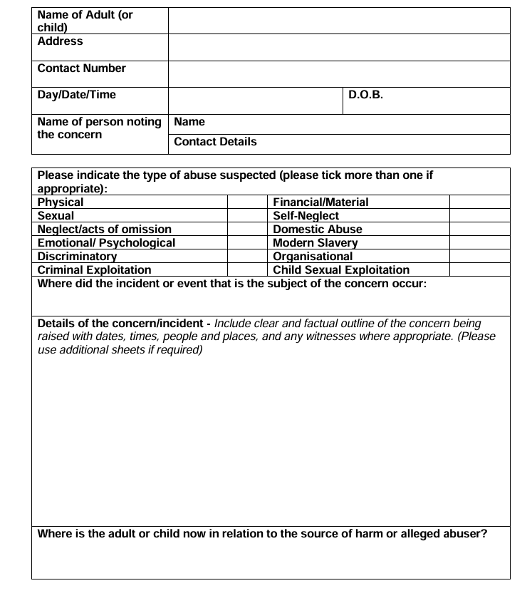

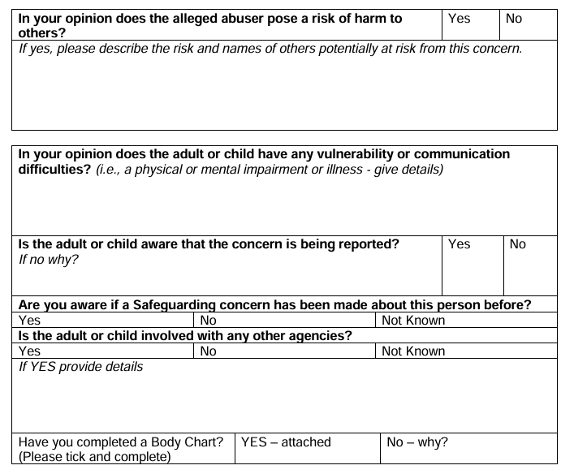
This form once completed should be emailed directly to the Designated Safeguarding Lead – christopher.joy@woodfordwells.org.uk - following which you should confirm with them that they have received it.
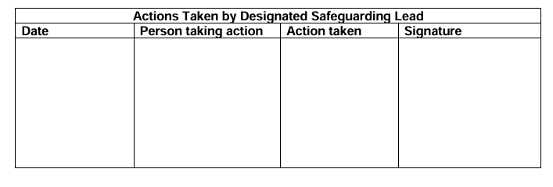

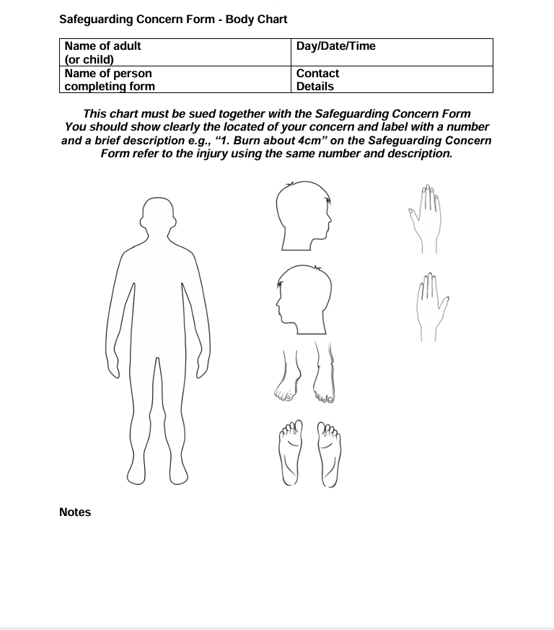

Guidance on completing the Police Now Safeguarding Concern Form

It is important that this Safeguarding Concern Form and accompanying Body Map is fully completed in a timely manner.
The details are important and in order to help the Designated Safeguarding Lead respond and refer appropriately you should follow the guidance below.
• Enter all the admin details including date of birth (this will be asked for when a safeguarding referral is made to either Social Services or the police)
• Include full names (not initials) • Make sure the concern is given in detail using the words of the adult or child who the concern is about
• Don’t report what other people have told you – they must write their own Safeguarding Concern Form
• Only write about one adult or child on each form
• Remember that concern forms may be used in court cases and inquests as primary documents – so they must be complete, legible, and accurate
• Make sure you use the club’s Safeguarding Concern Form to record your concern. Do not use any other forms or simply a piece of paper. Writing on other forms can cause confusion and errors
• If you jotted your notes down on a piece of paper whilst talking with the adult or child or immediately afterwards, you should attach these to the completed form
• If you cannot access a copy of the Safeguarding Concern Form, then contact the Designated Safeguarding Lead Christopher Joy as soon as you are able to who will supply the form for you
• Once completed the Safeguarding Concern Form should be emailed to christopher.joy@woodfordwells.org.uk
• Please alert the Designated Safeguarding Lead to the safeguarding concerns as soon as possible. It can take several hours to deal with even urgent concerns and the earlier we start the better
• Finally, ensure you sign, date and time the form.

Appendix B
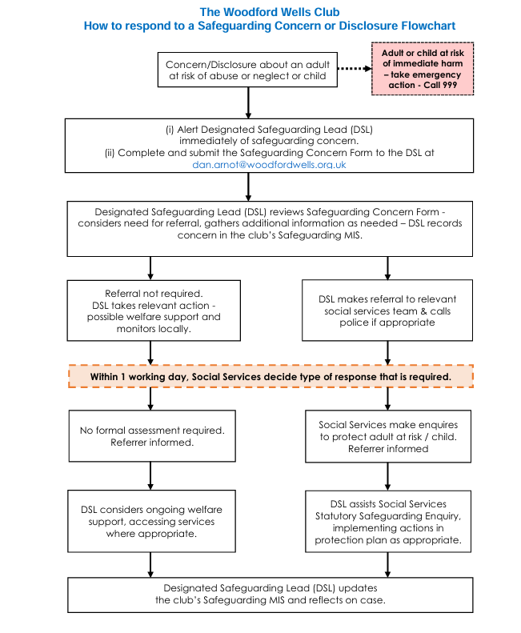

Appendix C
Preserving Evidence following a Safeguarding Concern or Disclosure
• Your first concern is the safety and welfare of the abused person. However, your efforts to preserve evidence may be vital.
• When Police involvement is required, they are likely to be on the scene quickly. Preservation of evidence is crucial if the Police investigation is to be effective.
• What you DO OR NOT DO in the time whilst you are waiting for the Police to arrive may make all the difference.
The following checklist aims to help you to ensure that vital evidence is not destroyed. In situations of physical and/or sexual assault:
a) If the abused client has a physical injury and it is appropriate for you to examine, always obtain their (or parent’s) consent first.
b) Do not touch what you do not have to. Wherever possible leave things as they are. Do not clean up, do not wash anything or in any way remove fibres, blood etc. If you do have to handle anything at the scene keep this to a minimum.
c) Do not touch weapons unless they are handed directly to you. If this happens, as before, keep handling to a minimum. Place the items/weapons in a clean, dry paper bag.
d) Preserve the abused person’s clothing and footwear, do not wash, or wipe them. Handle them as little as possible.
e) Preserve anything that was used to comfort the abused person, for example, a blanket.
Following allegations of physical and/or sexual assault, consideration will be given to organising a medical examination of the abused person and the alleged perpetrator.
The decision to carry out an examination will be taken during the strategy discussion/meeting. Any examination will be carried out by a Forensic Medical Examiner who will be contacted by the Police.
Methods of preservation:
a) For most things use clean brown paper, if available, or a clean brown paper bag or a clean envelope. If you use an envelope do not lick it to seal.
b) For liquids use clean glassware.
c) Do not handle items unless necessary to move and make safe.
It is acknowledged that completion of all of the above tasks may not be possible in a traumatic situation - you are urged to do the best that you can.

